**Sprint 3 Plan, Detective Dollar**

Detective Dollar Team. Completion by Monday 11/13/23

**Goal:** A list and line graph will display the past and current expense data. And other user interface additions will be added

**Task Listing:**

User Story 1: As a user, I will be able to look at my previous daily, monthly, and yearly expenses

1. Create a mockup to view previous daily, monthly, and yearly expenses. (< 45 mins)
2. Create a new page on the navigator where the past expenses will be displayed (< 30 mins)
3. Implement the “calendar” of past expenses ( > 5 hours)

Total for User Story: 6 hours

User Story 2: As a user, I will be able to see my past expenses in a line graph to see past trends in my spending

1. Create a new page to display the line graph (< 15 mins)
2. Determine the queries required to create the line graph (< 45 mins)
3. Design the UI for the line graph and implement it into the app ( > 3 hours)

Total for User Story: 4 hours

User Story 3: As a user, when adding an expense, I can add an image of the bill or receipt

1. Create an add image button to the add expense page ( > 30 mins)
2. Create the UI to have the user select images from their library or allow them to take a photo ( < 2 hours)
3. Store the imputed image so the user can look at it later ( < 2 hours)
4. Create an info button on each expense on the home page that goes to a pop-up window with the image (< 2 hours)

Total for User Story: 6.5 hours

User Story 4: As a user, I will receive a pop-up when adding expenses to confirm my new expense

1. Create the UI to add the pop-up after the add expense button is pressed (< 2 hours)

Total for User Story: 2 hours

User Story 5: As a user, when adding expenses, I can select a previously made category or add a new one

1. Create a drop-down with previous categories inputted (< 1 hour)
2. Have a field that allows the user to input the new category ( < 30 mins)
3. Create a category table in db to store the category names ( > 4 hours)

Total for User Story: 5.5 hours

User Story 6: As a user, my expenses and expense charts will be displayed in my local time

1. Figure out the queries required to access the time zone from the user's device
2. Store the user's time zone…

Total for User Story: **Undecided**

User Story 7: As a user, after I add an expense, the input fields will be cleared so that I can easily add a new expense

1. Remove the current input from the fields after the add button is pressed ( < 2 hours)

Total for User Story: 2 hours

**Team Roles:**

Thomas: Developer/ Project Manager

Hersh: Developer/ UX designer

Rohan: Developer

Ben: Developer

Cecile: Developer/ Scrum Master

**Initial Task Assignment:**

Thomas ➡ User Story: 1 Task: 2, 3 ;

Hersh ➡ User Story: 1 Task: 1; User Story 3 Task: 1- 4

Rohan ➡ User Story: 6 Task: 1 - 2

Ben ➡ User Story: 4 Task: 1; User Story: 5 Task: 1,2; User Story 7 Task 1

Cecile ➡ User Story: 2 Task: 1 - 3 ;

**Initial Burnup Chart:**

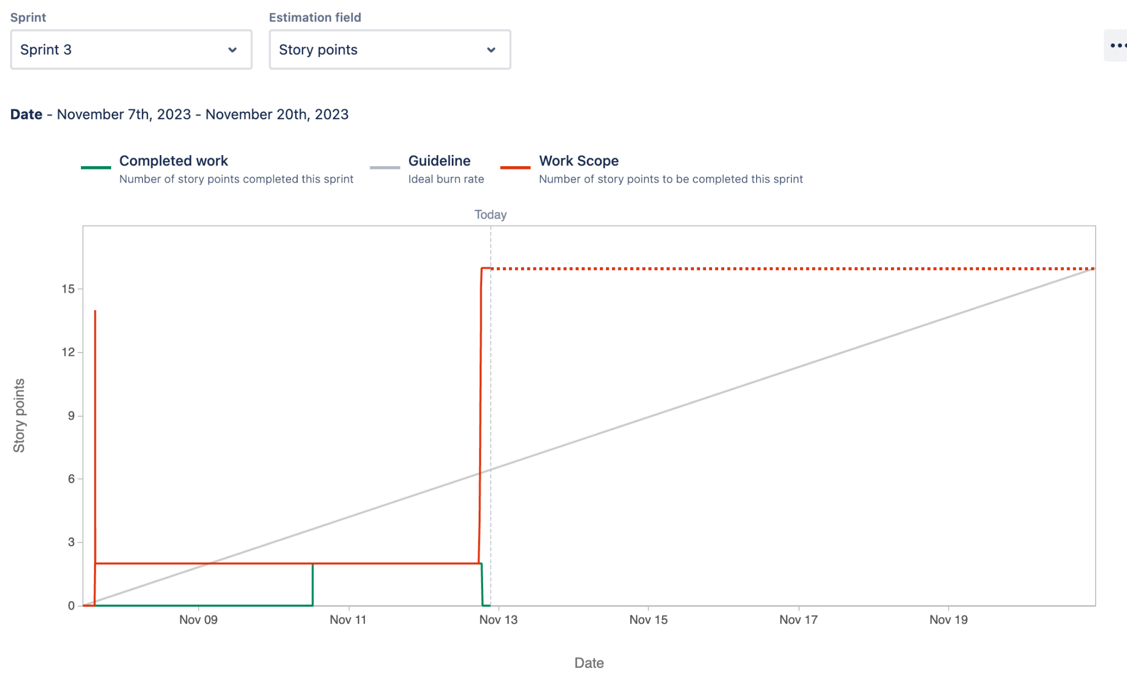

**Initial Scrum Board:**

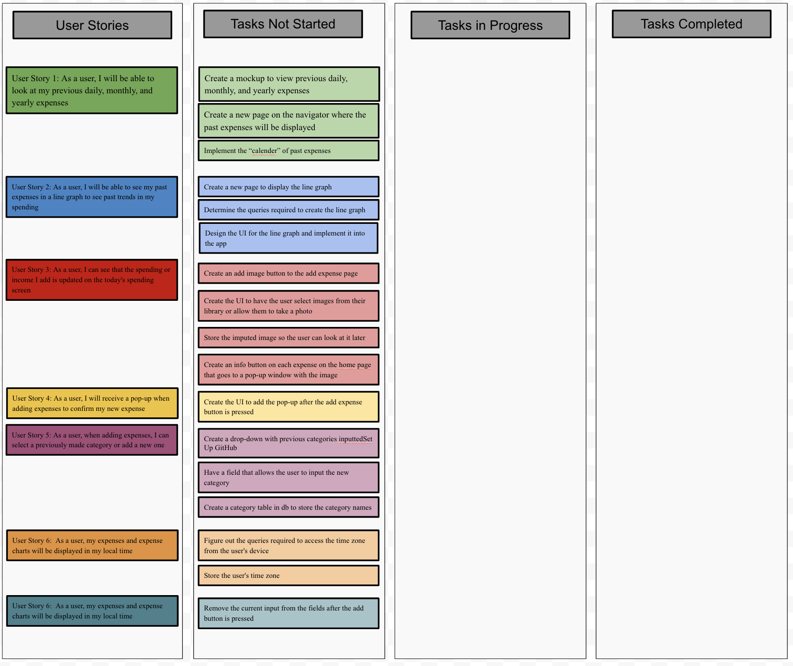

**Scrum Times:**

Mondays: 10am - 10:45 with TA

Thursdays: 4:15pm - 5:15pm

Sundays: 5:30pm-6:30pm